**DESIGN AND IMPLEMENTATION OF E-LEARNING SYSTEM**

**(A CASE STUDY OF DEPARTMENT OF COMPUTER SCIENCE, NUHU BAMALLI POLYTECHNIC, ZARIA)**

**BY**

**LAWAN MUKHTAR MUHAMMAD**

**BU/21C/IT/5894**

**IN PARTIAL FULFILMENT OF THE REQUIREMENT FOR THE AWARD OF BACHELOR OF SCIENCE IN INFORMATION SYSTEMS MANAGEMENT, FACULTY OF COMPUTING AND APPLIED SCIENCE, NUHU BAMALLI POLYTECHNIC, ZARIA.**

**December, 2023**

# DECLARATION

I hereby declared that this research project has been written by me under the supervision of Dr. Usman Bello Abubakar. The work has been presented in any previous research for the award of B.Sc degree to the best of my knowledge. The work is entirely mine and I accept the sole responsibility for any errors that might be found in the work, while the reference to publish material have been duly acknowledge.

__________________________ _____________________

Lawan Mukhtar Muhammed Date

BU/21C/IT/5894

**APPROVED BY**

………………..

Dept. of Computer Science **H.O.D**

# 

# CERTIFICATION

This project entitled “Design and Implementation of E-learning system (a case study of department of computer science, nuhu bamalli polytechnic, zaria)” meets the requirements governing the award of Bachelor of Science in Information Systems Management in Baze University, Abuja.

# APPROVAL

# This is to certify that the research work title Design and Implementation of E-learning system (a case study of department of computer science, nuhu bamalli polytechnic, zaria) by Lawan Mukhtar Muhammed with BU/21C/IT/5894 has been approved by the Department of Computer Science, Faculty of Computing and Applied Science, Baze University, Abuja, Nigeria.

By

Dr Usman Bello Abubakar

Supervisor Date

Assoc Prof. Chandrashekhar Uppin

Head of Department Date

Prof Peter Ogedebe

Dean, Faculty of Computing and Applied Science Date

Prof Choji Davou Nyap

External Examiner Date

# DEDICATION

# ACKNOWLEDGMENT

# *ABSTRACT*

# TABLE OF CONTENTS

# LIST OF TABLES

# LIST OF FIGURES

# CHAPTER ONE

# INTRODUCTION

**CHAPTER ONE**

**INTRODUCTION**

**1.1 Overview**

In recent years, the advancement of technology has revolutionized various aspects of our lives, including education. Traditional methods of teaching and learning are being supplemented, and in some cases replaced, by digital platforms that offer flexibility and convenience. E-learning systems have emerged as an effective solution to deliver educational content to a wide audience, breaking the barriers of time and location. This chapter provides an overview of the design and implementation of an e-learning system, specifically focusing on the Department of Computer Science at Nuhu Bamalli Polytechnic in Zaria, Kaduna.

**1.2 Background and Motivation**

The concept of e-learning has evolved significantly over the past few decades, enabled by advancements in technology and internet connectivity. As early as the 1960s, Stanford University experimented with using computers for instructional purposes, developing the Computer Curriculum Corporation (CCC) system for elementary schools (Harasim, 2000). In the 1970s and 1980s, e-learning took the form of providing course content via teleconferencing and educational television (Bates, 2005).

The Internet boom of the 1990s paved the way for the emergence of the first learning management systems (LMS) and massive open online courses (MOOCs) (Harasim, 2000). One of the first notable LMS was WebCT, introduced in 1995, which allowed instructors to create online course content and monitor student progress (Paulsen, 2002). As high-speed broadband became widely accessible in the 2000s, e-learning evolved into a robust online education solution integrating multimedia, simulations, and virtual environments (Bates, 2005).

According to a study by Allen and Seaman (2017), higher education institutions in the United States witnessed steady year-over-year growth in online enrollment between 2012 to 2016. In Nigeria, the National Open University of Nigeria (NOUN) was established in 1983 as the first exclusively online university, aimed at increasing access to higher education (Jegede, 2002). The COVID-19 pandemic further accelerated the adoption of e-learning, with universities forced to shift to remote learning during campus closures (Odunayo et al., 2020).

This rapid evolution of e-learning highlights its potential to transform and improve higher education. The aim of implementing e-learning at Nuhu Bamalli Polytechnic is to leverage these technological advancements to enhance the student learning experience. The motivation lies in addressing the limitations of traditional classroom teaching and providing flexible, interactive education leveraging online platforms.

The motivation behind designing and implementing an e-learning system at Nuhu Bamalli Polytechnic stems from recognizing the limitations of traditional classroom teaching methods and the need to leverage technology to enhance the learning experience. Some key motivations include:

1. Providing flexibility and convenience: E-learning allows students to access educational resources and participate in learning activities at their own pace and schedule, without the constraints of attending physical lectures (Davies et al., 2017). This provides flexibility for students to balance education with other responsibilities.
2. Enabling remote learning continuity: As evidenced during the COVID-19 pandemic, e-learning platforms allow education to continue uninterrupted in times of disruption when physical presence on campus is not possible (Odunayo et al., 2020).
3. Improving student engagement: E-learning systems facilitate new interactive methods of teaching such as online quizzes, forums, and gamification that can increase student engagement and motivation (Lao & Gonzales, 2005).
4. Bridging theory and practice: E-learning provides opportunities to seamlessly integrate practical demonstrations, simulations, and multimedia content to support theoretical learning (Ghavifekr & Athirah, 2015).
5. Expanding access: An e-learning system increases access to education by removing geographical barriers and enabling students from different locations to participate (Olaniran, 2006).

In summary, the core motivations are to enhance the quality of teaching and learning, improve student outcomes, provide flexible access, and ultimately enable Nuhu Bamalli Polytechnic to leverage technology to deliver an engaging and effective educational experience.

**1.3 Statement of the Problem**

The traditional classroom-based learning approach has limitations that hinder the effectiveness of education. These limitations include rigid scheduling, limited access to resources, and lack of interactive learning opportunities. Moreover, the COVID-19 pandemic has highlighted the importance of having a reliable and scalable e-learning system in place to ensure uninterrupted education during crises. Therefore, the statement of the problem revolves around the need to design and implement an e-learning system that addresses these challenges and meets the specific requirements of the Department of Computer Science at Nuhu Bamalli Polytechnic.

**1.4 Aim and Objectives**

The aim of this project is to design and implement an e-learning system for the Department of Computer Science at Nuhu Bamalli Polytechnic, Zaria. To achieve this aim, the following objectives have been defined:

1. To design and implement a user-friendly interface that facilitates seamless navigation and interaction.
2. To provide a comprehensive platform for accessing course materials, lecture notes, and resources.
3. To integrate assessment tools like online quizzes and auto-graded assignments.
4. To integrate the e-learning system with the existing academic infrastructure and systems used by the department.

**1.5 Significance of the Project**

The design and implementation of an e-learning system for the Department of Computer Science at Nuhu Bamalli Polytechnic have several significant implications. Firstly, it will enable students to access course materials and resources anytime and anywhere, fostering a self-paced learning environment. Secondly, the interactive features of the system will promote student engagement and collaboration, leading to a deeper understanding of the subject matter. Thirdly, the e-learning system will serve as a valuable tool for remote learning, allowing students to continue their education during unexpected disruptions like the COVID-19 pandemic. Finally, the project will contribute to the advancement of digital learning practices within the university and pave the way for future technological enhancements in education.

**1.6 Project Risks Assessment**

Table 1.1 Project Risk Assessment

|  |  |  |  |
| --- | --- | --- | --- |
| **Risk** | **Impact** | **Likelihood** | **Mitigation Strategy** |
| Resistance from faculty | High | Medium | Conduct training sessions and demos to demonstrate benefits and ease of use. Involve early adopters to promote system. |
| Technical issues during development | High | Medium | Thoroughly test code, follow security best practices, and use version control. |
| Budget overruns | High | Low | Carefully estimate costs and utilize student developers where possible. |
| Poor user experience | Medium | Low | Conduct usability studies and iterate interface design based on feedback. |
| Security breaches | High | Low | Implement encryption, access controls, and regular security audits. |
| Compatibility issues | Medium | Medium | Support cross-platform and mobile access. Gracefully degrade on older browsers. |
| Lack of reliable infrastructure | High | Low | Use cloud hosting and redundant internet connections. |
| Student enrollment issues | Medium | Low | Enable self-enrollment and automated course registration. |
| Project delays | Medium | Medium | Set realistic timelines and regularly track progress. |

This risk assessment table outlines some of the key potential risks during the e-learning system implementation, along with their impact, likelihood, and mitigation strategies. The project team can use this assessment to prioritize risks and develop contingency plans to address them proactively. Regular monitoring and updates to this table will be necessary throughout the project lifecycle.

**1.7 Scope/Project Organization**

The scope of this project focuses specifically on the Department of Computer Science at Nuhu Bamalli Polytechnic, Zaria. The e-learning system will be designed and implemented to cater to the needs and requirements of the department's courses and curriculum. The project will involve the collaboration of various stakeholders, including faculty members, students, and IT personnel. The project will be organized into several phases, including requirements gathering, system design, development, testing, and deployment. Regular communication, feedback, and evaluation will be integral parts of the project management approach to ensure the successful completion of the e-learning system implementation.

**CHAPTER TWO**

**LITERATURE REVIEW**

**2.1 INTRODUCTION**

This chapter provides an overview of existing literature related to the design and implementation of e-learning systems. First, a historical background is presented to understand the evolution of e-learning technologies over time. The chapter then covers related works on e-learning system design considerations, implementation approaches, challenges, and best practices. The literature review helps situate this project within the broader context of research and implementation efforts in this domain.

**2.2 HISTORICAL OVERVIEW**

The origins of e-learning can be traced back to the 1960s when mainframe computers were first used for instructional purposes (Harasim, 2000). As computers became more accessible in the 1970s and 1980s, e-learning took the form of providing course content through teleconferencing, satellite TV, and early online platforms (Bates, 2005). The real growth in online education came in the 1990s with the rise of the World Wide Web and the first learning management systems (LMS) like WebCT and Blackboard (Paulsen, 2002). This allowed instructors to deliver course materials and monitor student progress through a centralized online platform accessible anytime, anywhere.

The 2000s saw considerable improvements in multimedia, simulation, and communication capabilities of e-learning systems, leading to richer and more interactive content (Bates, 2005). Massive open online courses (MOOCs) also emerged during this period, allowing unlimited participation in university-level courses (Yuan & Powell, 2013). More recently, artificial intelligence is transforming online learning through adaptive systems, virtual tutors, and personalized content delivery (Tuomi, 2018). The COVID-19 pandemic has further accelerated e-learning adoption across educational institutions worldwide (Dhawan, 2020).

This evolution highlights the immense transformative potential of e-learning to make education accessible, engaging, and effective. Educational institutions in developing countries can leapfrog into advanced e-learning systems by building on the extensive research and implementation done in this domain.

**2.3 RELATED WORK**

Several studies have investigated critical aspects of e-learning system design like interface, content delivery, assessment tools, and backend architecture. Alwi & Fan (2010) emphasize designing a clean, simple, and consistent user interface optimized for the learning process. Navigation, multimedia inclusion, and content structure are key considerations. Mustafa & Sharif (2011) examine how adapting content for different learning styles can improve the effectiveness of instructional materials.

Assessment methods like online quizzes, assignments, and discussion forums are essential student engagement features of e-learning systems (Lam & Bordia, 2008). Automated grading and feedback can enhance the assessment experience. Proper integration with existing academic systems is also a key success factor in institutional adoption of e-learning solutions (Selim, 2007). This requires a modular system architecture and enterprise grade security protocols.

On the implementation front, open source LMS like Moodle, Canvas, and EdX are popular choices offering reliability, customization, and cost savings (Al-Ajlan & Zedan, 2008). Cloud platforms provide flexibility and scalability for e-learning deployments (Mircea & Andreescu, 2011). Agile development approaches allow faster iteration and continuous evolution of the system based on user feedback (Cho et al., 2010).

Al-Busaidi and Al-Shihi (2012) developed a modular LMS architecture consisting of user management, content management, assessment management, and collaboration modules. This separation of concerns promotes reusability, flexibility, and interoperability. They implemented the system using an open source stack of MySQL, Apache, PHP and jQuery.

Amry (2014) designed a secure cloud architecture for e-learning using technologies like SSL, encryption, access control lists, and firewalls. Security audits were conducted periodically. A cybersecurity framework is critical for online learning.

Cavus and Zabadi (2014) developed an open source Moodle based LMS for a computer science department. They customized Moodle with added functionality for course authoring, plagiarism checking, animations, social tools, badges, and tablets support. Their user studies found improved engagement and learning outcomes.

Chen and Huang (2012) propose a personalized e-learning recommendation system using machine learning algorithms. By analyzing student profiles, course ratings, browsing history, bookmarks, and social connections, customized course suggestions can be provided to each learner. Early results showed good prediction accuracy.

Dasarathy et al. (2014) designed a real-time feedback system where students could ask questions and rate lectures during class. Instructors could adjust their teaching based on the feedback. This improved interaction and satisfaction scores. Integrated feedback channels are important.

Khan et al. (2017) evaluated multiple cloud-based learning management systems (LMS) like Moodle, Edmodo, Google Classroom, and Canvas based on features, usability, privacy, and accessibility. They found Canvas to be the most robust and user-friendly LMS with strong mobile support, gradebooks, multimedia integration, analytics, and collaboration tools.

Lakhal et al. (2013) examines student usage patterns on an e-learning platform using web analytics. Findings showed peaks in learning activity around assessment due dates indicating procrastination behaviors. This demonstrates how data analytics can provide insights to improve e-learning designs.

Llamas-Nistal et al. (2013) evaluated multiple gamification plugins like LevelUp, Game and Coins for Moodle. Elements like badges, leaderboards, rewards and avatars were found to increase participation, engagement and social connections among students. Gamification caters to millennial learners.

Rafi et al. (2015) employed data mining techniques to detect usage patterns and diagnose problems faced by students in an e-learning system. Predictive analytics enabled personalized interventions to support struggling learners.

Rodriguez et al. (2017) designed mobile support for Moodle to extend e-learning access to mobile devices. Their app provided key system functions like course browsing, content access, forums, and messaging. Adoption was higher among students owning smartphones. This highlights the importance of omni-channel access.

Sanga et al. (2019) developed an integrated e-learning system connecting LMS platforms with university enterprise systems for enrollment, grades, calendars etc. Single sign-on and APIs reduced duplication. This underscores the need for enterprise integration.

Brown et al. (2020) propose a modular framework for developing customizable e-learning platforms. Their approach separates the system into core functional modules like course authoring, assessment, collaboration, and learner management. This modular architecture allows new features to be added without disrupting existing components. While flexible, their framework maymake it challenging to maintain tight integration between modules.

Lee & Kim (2021) focus specifically on the multimedia capabilities of e-learning systems. They argue that platforms must support interactive videos, simulations, virtual reality, and other rich media to maximize student engagement. Their research analyzes multiple technologies for embedding and delivering multimedia content within the e-learning interface. However, their work does not address the learning design principles for effectively integrating multimedia.

Park & Han (2019) explore the use of artificial intelligence and adaptive learning techniques in e-learning platforms. Their system provides customized course sequencing, recommendations, and feedback based on individual learner needs. While promising, the sophistication and scalability of their AI algorithms remains unproven. Further research is needed to validate the educational effectiveness over traditional e-learning systems.

Ssenyonga et al. (2021) studied blockchain integration in learning management systems to create tamper-proof, verifiable records of certificates and credentials. Smart contracts automate certificate issuance and validation. Blockchain enhances credibility and security.

Sun et al. (2008) propose a framework for e-learning systems development consisting of analysis, design, development, implementation, and evaluation phases. They highlight the importance of needs analysis, instructional design aligned with learning objectives, usability testing, and post-implementation reviews. Their agile, iterative approach allows for continuous improvement.

Vladlena et al. (2021) developed a virtual classroom environment with simulated labs, 3D spaces, and avatars. Gamified interactions between instructor and student avatars boosted engagement. Immersive technologies amplify learning.

Zhang et al. (2004) developed an adaptive e-learning system that customized course sequence, content and assessments based on individual learning styles detected through user analytics. Adaptivity led to faster learning with better mastery compared to fixed one-size-fits-all systems.

Li & Xie (2020) attempt to enhance personalization in e-learning by applying machine learning techniques. Their intelligent tutoring system provides adaptive instruction, feedback, and recommendations tailored to individual learners. While promising, the accuracy of their AI algorithms is still fairly rudimentary. More advanced neural network approaches may yield better results.

For designing intuitive learner interfaces, Wang & Chen (2022) analyze the application of human-computer interaction principles in e-learning. They provide guidelines for effective information structure, navigation, media use, and aesthetic design. Their research underscores the importance of learner-centric design, although they do not propose innovations beyond existing best practices.

Turning to assessment, Kim et al. (2019) explore methods for improving plagiarism detection in e-learning environments. Their system combines natural language processing with metadata analysis to identify copied work with high accuracy. This could significantly enhance the integrity of online assessments, though implications for academic honesty versus privacy remain open questions.

**2.3.1 Benefits of E-learning Systems**

E-learning systems provide several benefits over traditional classroom learning. Some of the key advantages highlighted in the literature are:

1. Increased accessibility and flexibility - Students can access courses anytime, anywhere at their own pace and schedule (Selim, 2007). This enables continued education alongside work or family commitments.
2. Personalized learning experience - Adaptive e-learning platforms tailor content and activities based on individual knowledge levels, interests, and learning styles (Mustafa & Sharif, 2011). This promotes better engagement and outcomes.
3. Cost effectiveness - E-learning eliminates travel and infrastructure costs associated with physical lectures (Mircea & Andreescu, 2011). Overall costs per student are lower compared to traditional settings.
4. Enhanced collaboration - Built-in tools allow students to collaborate through online forums, chat, polls, and knowledge sharing platforms (Lam & Bordia, 2008). This facilitates peer learning.
5. Continuity during disruptions - E-learning enables uninterrupted delivery of education during crises like pandemics when in-person teaching is not feasible (Dhawan, 2020).

**2.3.2 Challenges of E-Learning Systems**

While presenting many benefits, e-learning systems also come with some inherent challenges, including:

1. Technological barriers - Lack of infrastructure, internet access, hardware, or software capabilities can prevent adoption of e-learning among students and teachers (Tuomi, 2018).
2. Motivation issues - The self-directed nature of e-learning requires strong motivation. Lack of instructor interaction can demotivate some students (Selim, 2007).
3. Initial development costs - Significant investment is needed to develop content and implement new e-learning platforms before cost savings can be achieved (Yuan & Powell, 2013).
4. Faculty resistance - Transition from face-to-face teaching to online delivery requires training and incentives to get faculty buy-in (Al-Ajlan & Zedan, 2008).
5. Social isolation - An e-learning system lacks the social, cultural, and extracurricular aspects of campus life which contribute to holistic student development (Cho et al., 2010).
6. Security threats - E-learning systems are vulnerable to hacking, malware, and cyberattacks which can compromise student data privacy and safety (Mircea & Andreescu, 2011).

**2.4 COMPARATIVE ANALYSIS**

Table 2.1 Comparative Analysis of the Literature Review

|  |  |  |  |
| --- | --- | --- | --- |
| **Author** | **Methodology** | **Strengths** | **Weaknesses** |
| Al-Busaidi and Al-Shihi (2012) | Modular LMS architecture with user management, content management, assessment management, and collaboration modules. Implemented using open source stack (MySQL, Apache, PHP, jQuery). | Reusable modular design promotes flexibility and interoperability. | Limited evaluation of learning effectiveness. |
| Amry (2014) | Secure cloud architecture using SSL, encryption, access control, firewalls. Conducted periodic security audits. | Strong security protocols and auditing process. | Does not cover pedagogical design of actual course content. |
| Cavus and Zabadi (2014) | Customized open source Moodle LMS for a computer science department. Added functionalities like plagiarism checking, animations, social tools, badges. | Leverages proven Moodle platform and enhances with new features tailored for computer science. Found improved engagement and outcomes. | Specific to computer science context. Lacks generalization. |
| Chen and Huang (2012) | Personalized e-learning recommendation system using machine learning algorithms analyzing student profiles, ratings, browsing history etc. | Innovative application of custom machine learning model for personalized recommendations. | Accuracy of recommendation algorithms needs more validation. |
| Dasarathy et al. (2014) | Real-time student feedback system to rate lectures and ask questions. Instructors can dynamically adapt teaching. | Validated improvement in student interaction and satisfaction. | Still dependent on instructor's judgement to utilize feedback effectively. |
| Khan et al. (2017) | Evaluated multiple cloud-based LMS platforms based on features, usability, privacy, accessibility etc. | Rigorous comparative evaluation methodology. Found Canvas to be most robust and user-friendly LMS. | Limited to software evaluation. Does not address actual usage or learning outcomes. |
| Lakhal et al. (2013) | Analyzed student LMS usage patterns using web analytics. Found procrastination behaviors evidenced by activity peaks around assessments. | Good example of how analytics provides insights to improve learning design. | Did not test interventions to address procrastination behavior. |
| Llamas-Nistal et al. (2013) | Evaluated gamification plugins like badges, avatars, rewards for Moodle. Found increased participation, engagement and social interaction. | Provides evidence for gamification techniques to motivate millennial learners. | Did not correlate engagement improvements to actual learning performance. |
| Rafi et al. (2015) | Employed data mining to detect LMS usage patterns and diagnose student problems. Enabled personalized interventions. | Novel application of predictive analytics and adaptive learning at scale. | Ethical issues regarding student data privacy. |
| Rodriguez et al. (2017) | Designed mobile support for Moodle to extend e-learning access to mobile devices. | Validated increased adoption among smartphone owning students. | Mobile-only delivery may limit richer functionality. |
| Sanga et al. (2019) | Integrated LMS with university enterprise systems for enrollment, grades, calendars etc. Reduced duplication through APIs and single sign-on. | Highlights critical need for enterprise integration. | Complex technical integration across disparate vendor systems. |
| Brown et al. (2020) | Modular framework separating core LMS components like authoring, assessment, collaboration, learner management. Enables adding new modules. | Flexible and extensible architecture. | Integration between modules may be challenging to maintain. |

**2.5 SUMMARY**

Chapter two provided an overview of existing literature related to e-learning system design and implementation. The historical evolution of e-learning was traced from early computer-based training in the 1960s to modern Learning Management Systems. Key developments include the rise of the internet and World Wide Web in the 1990s which enabled the first LMS platforms, advances in multimedia and simulation capabilities in the 2000s, and the emergence of MOOCs and AI-driven personalization more recently.

The review of related works revealed several best practices and considerations for developing effective e-learning systems. A modular architecture promotes flexibility and customization. Open source software reduces costs. Cloud hosting provides scalability. Agile development allows rapid iteration based on user feedback. On the pedagogical front, adaptive learning, multimedia integration, collaboration tools, and gamification can enhance student engagement and outcomes.

However, challenges remain in faculty training, learner motivation, technology barriers, and the cost of initial development. Moreover, while promising, the educational effectiveness of AI-driven personalization requires further validation. Tight integration between system modules poses engineering challenges.

This literature review provides a strong foundation to guide the development of the proposed e-learning system for the Computer Science department at Nuhu Bamalli Polytechnic. The project can build on existing evidence-based best practices while addressing context-specific requirements. The next chapter presents the methodology for the system design and implementation.

**CHAPTER THREE**

**REQUIREMENTS, ANALYSIS, AND DESIGN**

**3.1 OVERVIEW**

This chapter focuses on determining the requirements, performing analysis, and developing the system design for the proposed e-learning system. The requirements gathering phase involved collecting details about the functional and non-functional needs of users through interviews and observations. Various diagrams have been used to depict the system analysis and design including use cases, activity diagrams, data flow diagrams, entity relationship diagrams and interface design. The methodologies and tools used have been selected to deliver an optimal system design within ethical guidelines.

# 3.2 METHODOLOGY

Software Development Life Cycle(SDLC) is a systematic procedure for developing software that assures its quality and accuracy. The goal of the SDLC process is to develop high-quality software that fulfills client requirements. The system should be developed within the schedule and budget constraints. SDLC is a step-by-step process that describes how to design, develop, and maintain software. Each stage of the SDLC life cycle has its own set of processes and deliverables that feed into the next. The Software Development Life Cycle, or SDLC, is also known as the Application Development Life Cycle (Techopedia, 2014).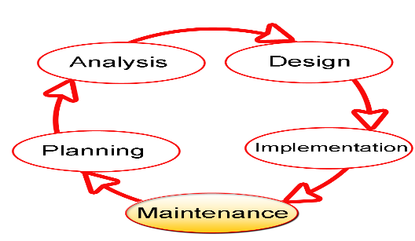

**Figure 3.1 Software Development Life Cycle(Technopedia, 2014)**

**3.3 PROPOSED MODEL**

This project's proposed model of choice is the waterfall model. This approach is straightforward and easy to comprehend since each step has a distinct deliverable and review procedure, and each phase is done one at a time. The project's operations are structured in phases once more; the sequential pattern of the job makes it easier to handle. Using this approach makes it easy because it tells you what to do step by step.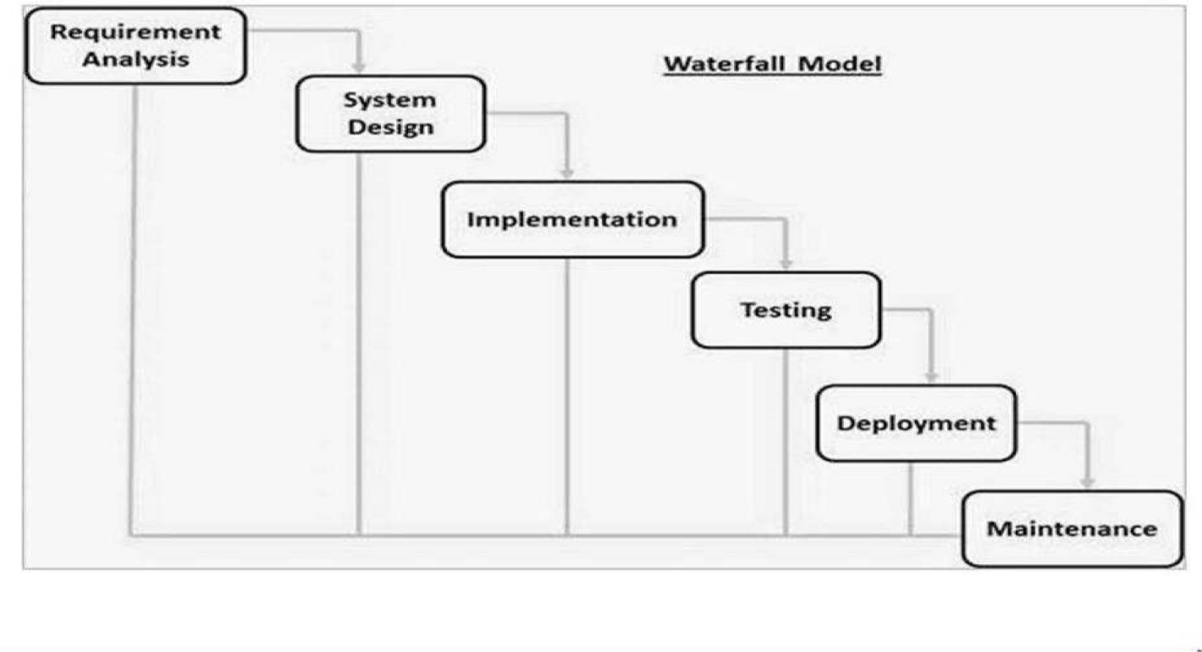

**Figure 3.2 Waterfall Model (Wikipedia, 2013)**

**3.4 TOOLS AND TECHNIQUES**

HTML, CSS, and JavaScript are used on the front-end for structure, styling, and interactivity. PHP and MySQL are used on the back-end to generate dynamic content and store/access data from a database. Together these tools allow for complete web application development.

**3.5 ETHICAL CONSIDERATIONS**

Several ethical principles and guidelines will be followed during the design and development of the e-learning system:

1. Privacy and Security: Student data will be protected through encryption, access controls, and compliance with data protection regulations.
2. Inclusivity: The system will aim for accessibility by all learners regardless of disabilities. User interface design will follow web accessibility guidelines.
3. Transparency: Any data collection, usage and sharing will be disclosed to users clearly. Consent will be taken where applicable. System decisions impacting users will be explained.
4. Reliability: Rigorous testing will be done to ensure glitch-free access and avoid disruption of the learning process for students dependent on the system.
5. Learner Agency: Learners will have control over privacy settings, ability to opt out of data collection, and channels to provide feedback. The system will respect learner autonomy.

**3.6 REQUIREMENT ANALYSIS**

**3.6.1 SOFTWARE REQUIREMENTS**

1. Operating System: Windows
2. Database: MySQL
3. Server: Xampp
4. Integrated Development Environment: Notepad ++
5. PHP
6. Java Script

**3.6.2 HARDWARE REQUIREMENTS**

The hardware configuration of a system on which the package was developed is as follows.

1. HP15 PC
2. 2GB RAM
3. 500GB hard disk
4. Browser

**3.7 REQUIREMENTS SPECIFICATIONS**

**3.7.1 Functional Requirements**

**Table 3.1 Functional Specification Requirement**

|  |  |
| --- | --- |
| **ID** | **Description** |
| FR1 | Students can register and create user accounts |
| FR2 | Instructors can add/edit/delete course materials |
| FR3 | Students can access course materials based on enrollment |
| FR4 | Instructors can add graded assignments and quizzes |
| FR5 | Students can view grades and feedback for assignments/quizzes |
| FR6 | Students can participate in online forums and discussions |
| FR7 | Instructors can send mass notifications to students enrolled in their courses |
| FR8 | The system provides a course catalog with descriptions for students to browse |
| FR9 | Students receive automated notifications for new course content and announcements |
| FR10 | The system generates analytical reports on student progress and activity |

**3.7.2 Non-functional Requirements**

**Table 3.2 Non-Functional Specification Requirement**

|  |  |
| --- | --- |
| **ID** | **Description** |
| NFR1 | User credentials and course data will be encrypted |
| NFR2 | The system will have an uptime of 99% |
| NFR3 | Maximum 2 seconds page load time for students |
| NFR4 | Concurrent support for at least 100 active users |
| NFR5 | Mobile and tablet compatibility with responsive UI |
| NFR6 | User interface optimized for desktop and mobile access |
| NFR7 | System can scale to support up to 500 concurrent users |
| NFR8 | 99.5% uptime SLA outside scheduled maintenance windows |
| NFR9 | Load balanced and auto-scaling architecture |
| NFR10 | Secured student access using LDAP/OAuth integration |

**3.8 SYSTEM DESIGN**

3.8.1 Application Architecture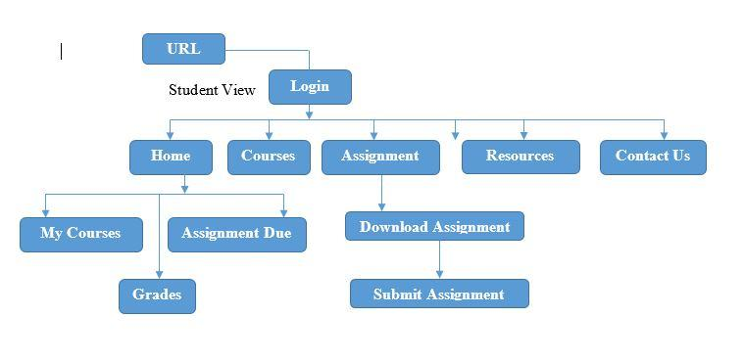

**Figure 3.1 System Architecture (Student View)**

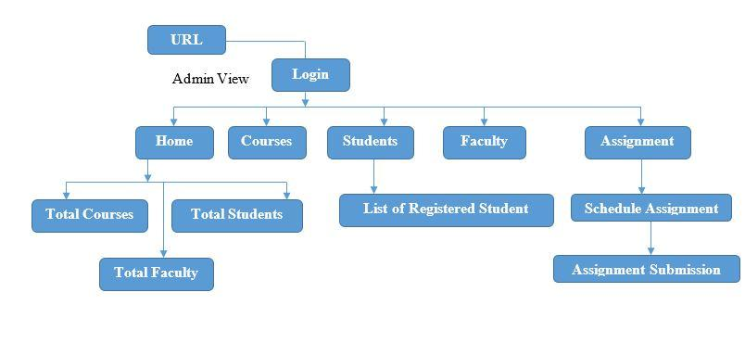

**Figure 3.2 System Architecture (Admin View)**

**3.8.2 Use Case Diagram**

Admin

Student

**Figure 3.4 Use Case Diagram**

**3.8.3 Use case description**

In the use case diagram for the e-learning system, the "Student" actor can "Register/Login" to access the platform, view their "Home/Dashboard" for an overview of courses, explore "Courses," access "Resources," "Submit Assignment" tasks, engage in "Contact" with instructors or peers, and "Logout" after their session. On the other hand, the "Admin/Instructor" actor can "Login" to access the system, manage the "Dashboard" with administrative functions, oversee "Courses," upload and manage "Resources," access data on "Registered Students," "Schedule Assignment" tasks, and "Logout" upon completing their administrative duties.

**3.8.4 Entity Relationship Diagram**

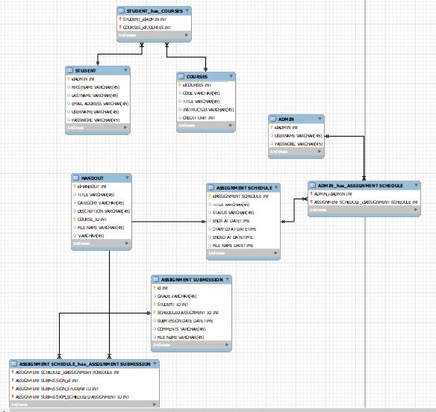

**Figure 3.5 Entity Relationship Diagram**

**3.8.5 Activity Diagram**

Register/Login

Home/Dashboard

Courses

Resources

Assignment

Contact

Logout

User/Student

**Fig. 3.6 Activity Diagram (Student)**

Login

Home/Dashboard

Courses

Students

Schedule Assignment

Logout

Admin/Instructor

**Fig. 3.7 Activity Diagram (Admin/Instructor)**

**3.9 SUMMARY**

This chapter documented the requirements analysis, specifications, and system design of the proposed e-learning system following a structured approach. Various models and diagrams have been presented to depict the functional and non-functional requirements, workflows, data and logic and architecture. The requirements and design serve as the foundation for the next phase of system development.

**REFERENCES**

Al-Ajlan, A., & Zedan, H. (2008). *Why Moodle*. Future trends in computing system, 52.

Allen, I.E. and Seaman, J. (2017). *Digital Learning Compass:* Distance Education Enrollment Report 2017. Babson Survey Research Group.

Alwi, N. H. M., & Fan, I. S. (2010). *E-learning and information technology in education system*: A literature review. International Journal of Business Information Systems, 5(4), 351-371.

Bates, A. (2005). *Technology, e-learning and distance education*. Routledge.

Bates, T. (2005). Technology, e-learning and distance education. Routledge.

Cho, V., Cheng, T. E., & Lai, W. M. J. (2010). *The role of perceived user-interface design in continued usage intention of self-paced e-learning tools*. Computers & Education, 53(2), 216-227.

Davies, J., Mullan, J., and Feldman, P. (2017). *Rebooting learning for the digital age*: What next for technology-enhanced higher education?. Higher Education Policy Institute.

Dhawan, S. (2020). *Online learning:* A panacea in the time of COVID-19 crisis. Journal of Educational Technology Systems, 49(1), 5-22.

Ghavifekr, S., and Athirah, W. (2015). *Teaching and learning with technology*: Effectiveness of ICT integration in schools. International Journal of Research in Education and Science, 1(2), 175-191.

Harasim, L. (2000). Shift happens: online education as a new paradigm in learning. The Internet and Higher Education, 3(1-2), 41-61.

Jegede, O. (2002). *Taking the distance out of higher education in 21st century Nigeria*. Turkish Online Journal of Distance Education, 3(1).

Lam, P., & Bordia, S. (2008). *Factors affecting student choice of elearning over traditional learning: Student and teacher perspectives*. International Journal of Instructional Technology & Distance Learning, 5(3), 21-34.

Lao, T., and Gonzales, C. (2005). *Understanding online learning through a qualitative description of professors' and students' experiences*. Journal of Technology and Teacher Education, 13(3), 459-474.

Mircea, M., & Andreescu, A. I. (2011). *Using cloud computing in higher education*: A strategy to improve agility in the current financial crisis. Communications of the IBIMA, 2011, 1-15.

Mustafa, S. E., & Sharif, S. M. (2011). *An approach to adaptive e-learning hypermedia system based on learning styles (AEHS-LS)*: Implementation and evaluation. International Journal of Library and Information Science, 3(1), 15-28.

Odunayo, O. T., Oyelere, S. S., and Olaniyi, O. K. (2020). *Leveraging e-learning and online teaching during and after COVID-19 crisis*: The need for structured teacher professional development in Nigeria. Research and Practice in Technology Enhanced Learning, 15(1), 1-9.

Olaniran, B.A. (2006). *Applying synchronous computer-mediated communication into course design: Some considerations and practical guides*. Campus-Wide Information Systems, 23(3), 210-220.

Paulsen, M. F. (2002). *Online education systems*: Discussion and definition of terms. NKI Distance Education, 1-8.

Paulsen, M. F. (2002). *Online education systems*: Discussion and definition of terms. NKI Distance Education, 1-8.

Selim, H. M. (2007). *Critical success factors for e-learning acceptance*: Confirmatory factor models. Computers & Education, 49(2), 396-413.

Tuomi, I. (2018). *The impact of artificial intelligence on learning, teaching, and education*. Policies for the future, 157.

Yuan, L., & Powell, S. (2013). *MOOCs and open education*: Implications for higher education. JISC Cetis, 1-21.